George Hedderly, bellfounder on two continents.

George Hedderly of Nottingham was the last of the Hedderly family to cast bells in England. He was a third generation founder, his grandfather Daniel having cast bells from as early as 1701 up to his death in 1766, first at Hanbury, Staffordshire, then at Bawtry, Nottinghamshire, and finally in Lincoln. Daniel’s son, Thomas I Hedderly learnt his trade under his father, but in 1741 took the opportunity to take over the Nottingham Bellfoundry when George III Oldfield died & his sons were not founders. On the death of Thomas I in 1778, his eldest son Thomas II took over but sadly he died prematurely in 1784, leaving the business to his younger brother, George. He had found it difficult to drum up business, and had even mortgaged the foundry buildings in an attempt to stay afloat.
Sometime in July 1793 the then 43 year old George shut up shop and bellfounding in Nottingham ceased after over 350 years of continuous trading. George promptly disappeared abandoning his new wife, Sarah, & infant child, Francis. In later years his younger brother John, a butcher, said he went to America after a family argument, and was heard of no more. Thus it was an ignominious end to the bellfoundry.

However George made a new life for himself in America, and this involved him in his previous trades as a framesmith (builder of knitting frames), a trade in which he was apprenticed, and bellfounder, briefly in New York, then in Philadelphia.

How he got to America is unknown, probably from Liverpool, but he arrived in first in Philadelphia where we have the first record of him, on Christmas Eve 1793 when he had a look at the 8 bells of Christ Church there. These were a complete ring of 8 bells by Thomas Lester of the Whitechapel bellfoundry cast in 1754. He seems to have moved on to New York and there quickly made the acquaintance of one John Bailey, a well known multi-talented Sheffield born artisan, and between them they entered a partnership to cast bells. This new business was quick to advertise itself and in the Daily Advertiser of 8th March 1794:
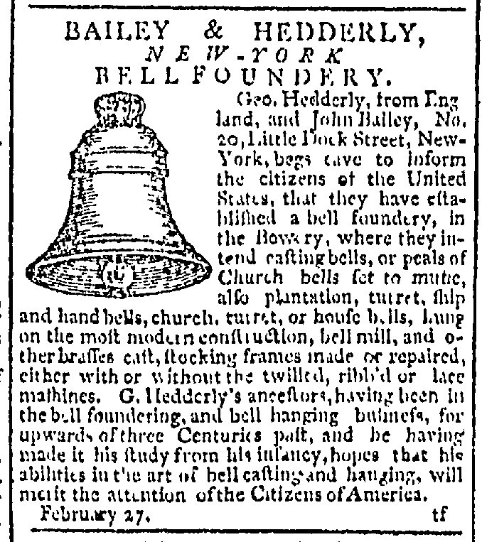

A similar advertisement occurs in the New Jersey Journal of 9th April.

Advertising pays, and quickly bells were cast. Currently four small bells are known, all dated 1794:
- At the Museum of the City of New York
- At the Reformed Church, New Platz, New York
- In private ownership
- Dyrham Park, The Garden House, Gloucestershire, UK

This partnership was destined to be short-lived for by April 1795 John Bailey was taking court action against George & Sarah Hedderly, presumably because of the breakup of the partnership. Now it interesting to note the presence of Sarah Hedderly in this case because she was not his second wife, Sarah, who he had married at Bottesford Church in June 1792, she had returned to Bottesford with their infant son after his departure to America, & eventually died there in 1812. The new Sarah in his life may have been a distant cousin. Anyway whatever the relationship, she gave birth to a son Edwin sometime in 1794.
It seems that George had returned to Philadelphia and by April 1795 and was working there. Correspondence exists which shows that initially at least he was building and repairing knitting frames, a trade he knew well as he had been apprenticed as a frame-smith in 1769. In this he seems to have been less than successful, but bells were always in his blood and he must have been letting the population know that he had abilities that way.

By 1797 we find the first newspaper advertisement, dated June 6th, in which he emphasises his house bells, and 2 months later he advertised in the Baltimore Daily Advertiser that he intended to be in that city for a few weeks on the same mission, selling house bells. However the advert mentions all forms of bells: Church, ship & turret bells.
The trip must have been successful and some work undertaken. Anyway knowledge of his work spread, and on 27th March 1801 the Commissioner for Public Buildings in Washington DC., America’s new capital city, then building the White House, wrote to one Mr Blodgett:

“We shall thank you to engage Mr Hedderly to come down as soon as possible & bring materials of the best quality for 12 bells. We agree to pay the price he fixes and pay the expences expressed in his estimate.... “

He moved quickly & proceeded to produce & hang the 12 house bells. Sadly none of these have survived the many changes to the White House over the years, indeed no house bells of his have been found either in England or America, yet. He clearly thought the new city a potentially lucrative area and he returned there in the autumn, again advertising in the local paper, the Washington Federalist of 12th October:
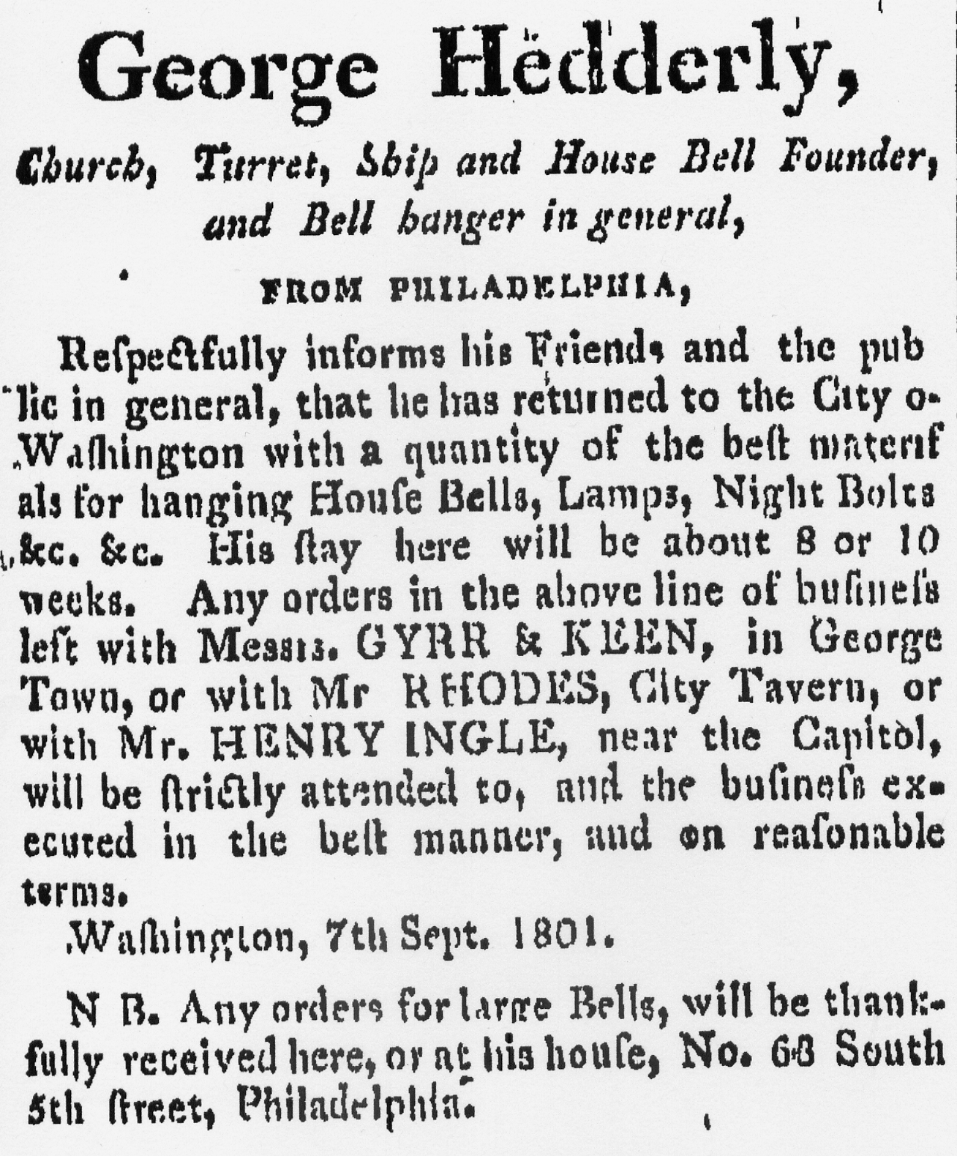

Whether he was actually casting large bells at this time is not known as none have been located, but it is clear that when he left Nottingham, he had every intention of setting up a foundry wherever he went, because he took with him some of the patterns for inscriptions, particularly initial crosses.

Anyway dealing with the highest level of American society probably resulted in his decision to become an American citizen and his petition is dated 8th July 1802.

The cost of building a furnace for melting large amounts of metal would not be inconsiderable and the earliest bells by him so far found are dated 1804 at:

1804
Doylestown Union Academy
Williamsport (PA) Court House
Raleigh (NC) Court House
possibly Shepherdsville Court House (KY).

That there are four bells this year suggests that he was already casting large bells by then, and in time more will come to light. Indeed, by 1801 bells were being cast in Philadelphia, but sadly they either have been lost, or have been recast, thus losing the identity of the founder.
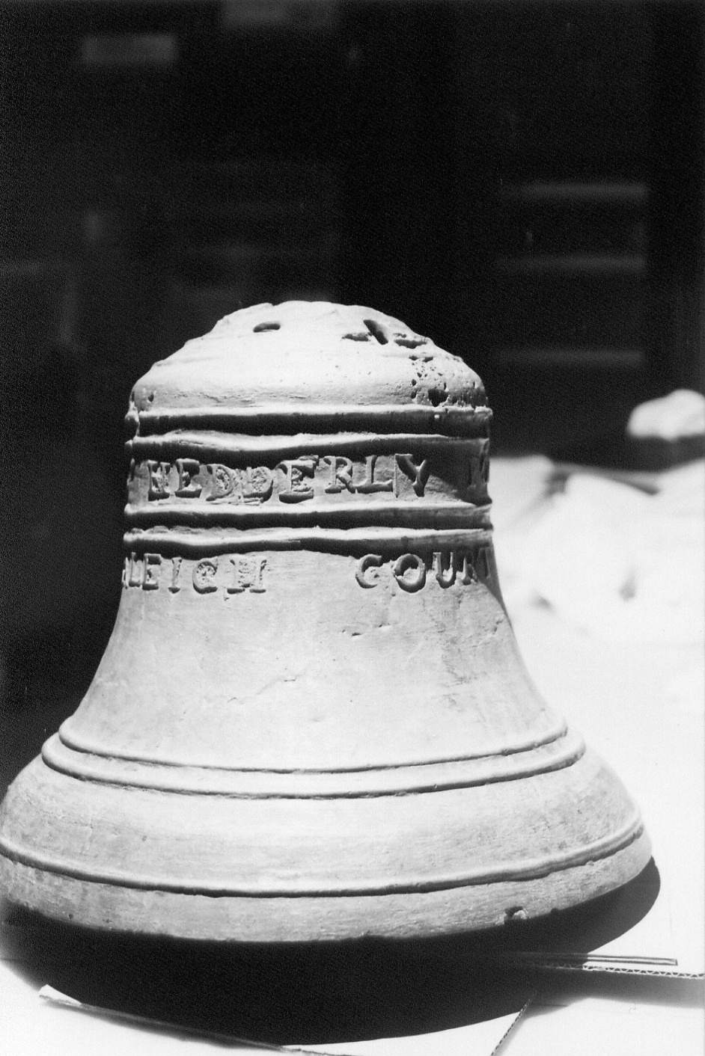
Raleigh Courthouse bell (photo by G. Dawson)
The fact that a bell is found as far away as North Carolina (and others even further afield are known) indicates that Hedderly had become well known, probably as the result of advertising in newspapers. Typical is probably this advert from the Aurora General Advertiser of 27th September 1805, which from the date at the bottom of it, had been used previously.
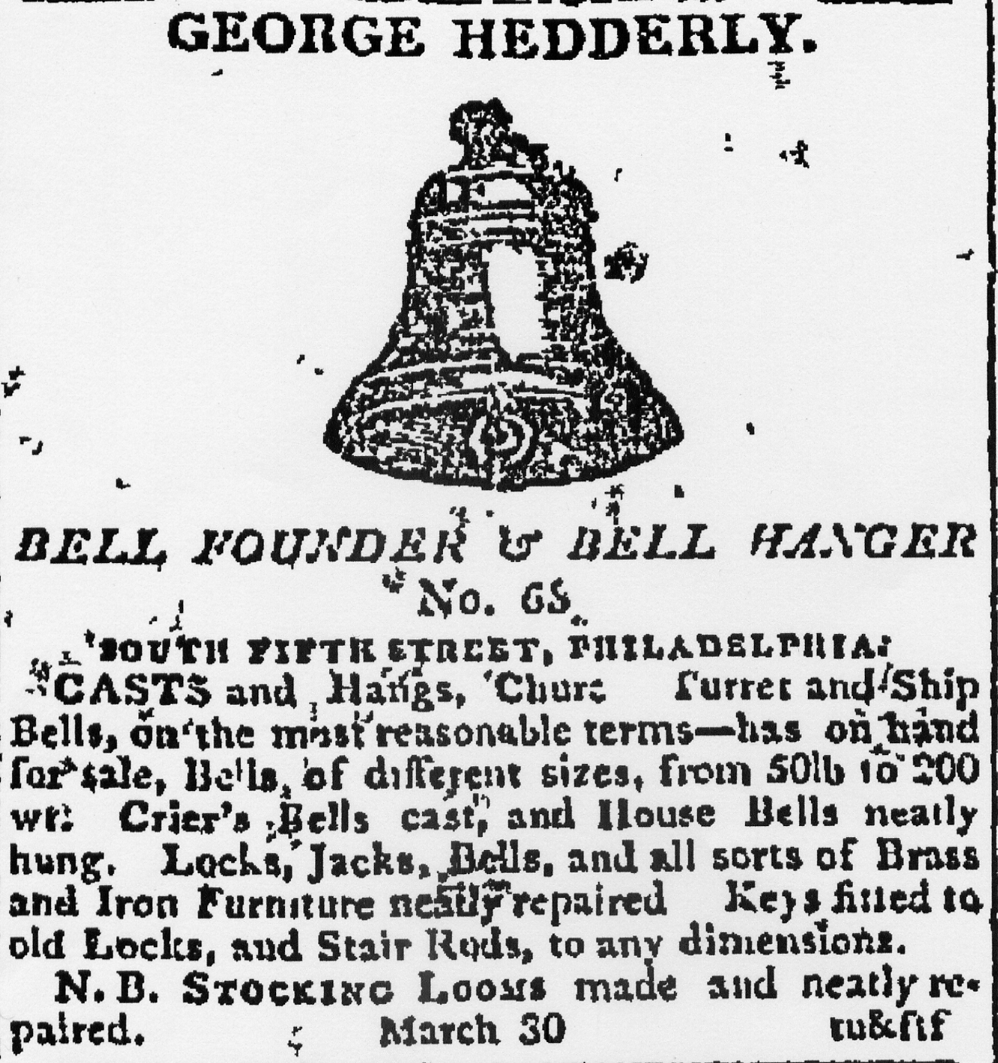

Bells now followed on a regular basis, and the following are currently known:
Diameter Weight
1805 Hillsborough Court House (SC) 28”
1806 Southwark Swedes church, Philadelphia (PA) 24.625” 2.2.20
1807 Sunbury (PA) 24.5”
Trenton (NJ) Presbyterian church 28” 4.1.2
Wellsberg (WV) Courthouse 16”
Womelsdorf (PA) Zion church 26.375” c5cwt
Pungoteague (VA) academy ?
1808 Hanover (PA), St Matthew 1 of 2 24.5”
“ 2 of 2 26”
1809 Charlestown (WV) Court House 16”
Charlottesville (VA) Court House ?
Milford (DE) academy 16.43” 1.0.10
Woodstock (VA) Courthouse 21”
1811 Hatboro Borough Hall ??
Wilkesbarre (PA) 30.75” 6.0.8
Philadelphia Naval Yard ?
1812 Philadelphia Naval Yard ?
1813 Toledo (OH) private ownership (origins unknown) 21”

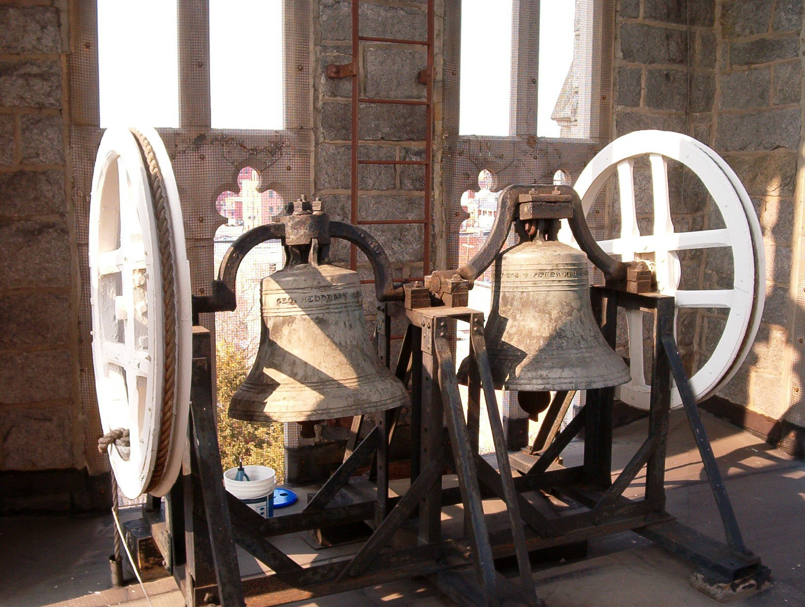
The Hanover bells, the only known work involving casting more than 1 bell.
(Photo by Colin Lord & Stuart Hale).

Bellfounding can only have been a small part of his trade, albeit lucrative when it turned up, and his ‘bread & butter’ must have been that indicated in his advertisements, general smiths work.
In the Philadelphia Christ Church Archives there are bills from him for ironwork:

27th April 1812 To cash pd g. Hedderly $56
16 October 1812 To do. [cash] g. Hedderly for gudgeons & etc $19.87
6 April 1813 to cash to geo Hedderly 11/ [$11.00]

This latter entry is just four days before his death. The reference to ‘gudgeons’ clearly indicates that he rehung the bells then, and indeed the existing gudgeons there are of the hooped type, that is one-piece with a central circle to avoid the canons. The advantage of this style is that the gudgeons can be accurately aligned on the headstock so they are in line and much easier to set up for the easy going of the bell. Now the earliest occurrence of this type of gudgeon seems to have been with the Eayres, at Kettering & St Neots in the mid 18th century. George Hedderly whilst still in Nottingham also used them on his last English church bell at Thistleton, Rutland in 1793.
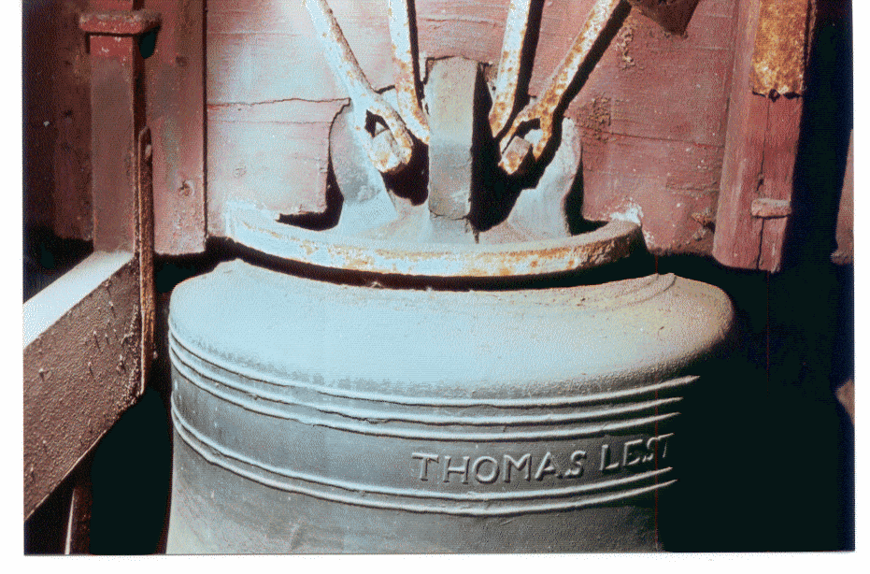
Christ Church 7th bell, showing the hooped gudgeons. Photo by G A Dawson

He died on 10th April 1813, having made a nuncupative (verbal) will the previous day. The two witnesses to his statements were Elizabeth Van Trump and Hannah Burns. His estate was not substantial. Elizabeth von Trumps deposition was:

Philadelphia May 3rd 1813. Then personally appeared Elizabeth Van Trump of the City of Philadelphia, Widow and on her solemn affirmation according to Law did declare & say that the annexed Paper Writing to which her name is subscribed as a Witness contains the testamentary words or the purport thereof which were pronounced by George Hedderly on the City of Philadelphia, Bellfounder in the said Paper writing mentioned, on or about the 9th day of April in the year of our Lord one thousand Eight hundred and thirteen, in his dwelling house & in his last sickness, in the hearing of the aforesaid Elizabeth Van Trump, and which words or the purport thereof she did hear the aforesaid George Hedderly declare to be his Last Will and Testament and the sais Testator desired her to bear Witness thereof or to that effect and the said Affirmant did further declare and say that the aforesaid Testator was at the time he pronounced the aforesaid testamentatory words of sound mind memory and understanding to the best of her knowledge & belief

Affirmed & subscribed the Elizabeth Van Trump
Day and year aforesaid
Before
Sam Bryan Reg[istra]r

The Abstract declares:
That his wife Sally [clearly Sally was the everyday version of Sarah!] and her children should have all his property.

The Inventory of his goods was published on 10th June 1813. Besides the usual effects there was:
7. A set of House bells $10
10. Bell hanging tools $2
11. A Lot of old metal $70
13. A lot of weights Scales chains etc $20

The Estate was finally settled on 14th July 1814 when the balance was $1799:49.

His eldest son, Edwin, continued bellfounding, and bells are known by him up to his premature death in 1821, aged just 27 years.

This however was not the end of the Hedderly connection with bells, for in the 1810’s both Hedderlys, father & son, worked with other people who went on to cast bells. Included in these are:
W Riland, in 1813.
Thomas Washington Levering in 1814, who cast known bells in his own right in 1815 & 1816.

Edwins known bells:
1813 Doylestown (PA) Courthouse
1815 Middletown (PA) St Peters Lutheran church
Lynchberg (VA) Methodist church
1821 Doylestown (PA) Bucks County Academy

Another son of George, Henry, clearly helped firstly his father, and probably his brother Edwin, in the foundry. He later moved to Indianapolis, Indiana, and it was there that he became acquainted with the bellfounder George W Hanks, who made copies of one of George Hedderlys notebooks in 1849, which contain data on bells cast in Nottingham from c 1777, some of which was otherwise unknown.

Acknowledgements:
John Hedderly, who has kindly made all his family researches available including the newspaper extracts.
Gary Trudgen for a copy of his article on the New York Bell foundery (in the American Bell Associations publication ‘The Bell Tower’ Vol.51, No.1 p.15.).
The Cincinnati Historical Society Library for the photocopy of the George Hanks Mss relevant to the Hedderlys.
Bruce Cooper at Christ Church Philadelphia.
Stu Hale & Colin Lord for photographs of the Hanover bells.

February 2013.
In RW 10/5/13
Updated: 12/5/13

