Holme Cultram, Cumbria

The important dated bell from here has arrived at Taylors for restoration, the church having been burnt in 2006.

It is dated 1462, not 1465 as reported by Walters in CBE etc. The full inscription reads:

[+] ihc [stop] thomas [stop] york [stop] abbas [stop] de [stop] holm [stop] cV [stop] dominio [stop] anno dni [stop] millº [diamond stop] ccccº [diamond stop] lxiiº

The diameter is 20.93" & it weighs 1.3.8. The canons have long been removed. The stop and lettering seem to be unique.

The bell is very important as there are so few dated bells between 1450 & 1500 (this bell, Worcester St Michael (in Cathedral cloisters), Salhouse, Grimley & Durham castle are the only ones to survive, a few, now recast are known).

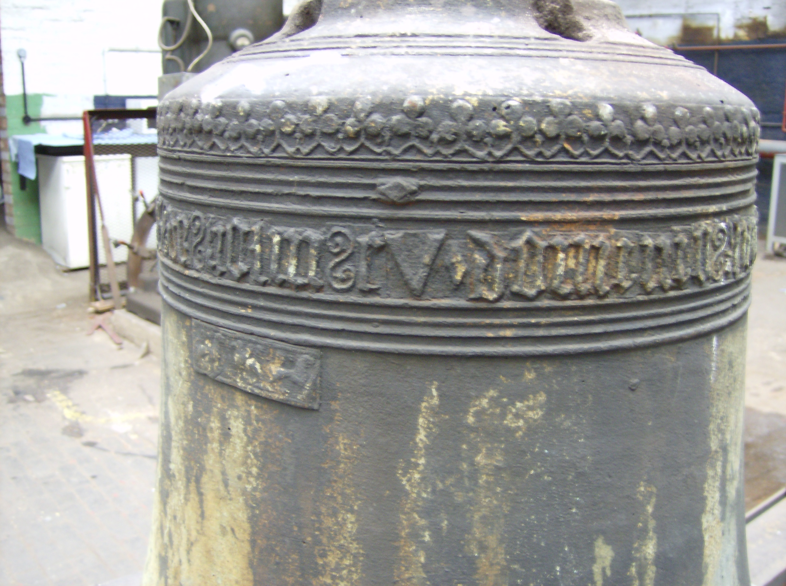

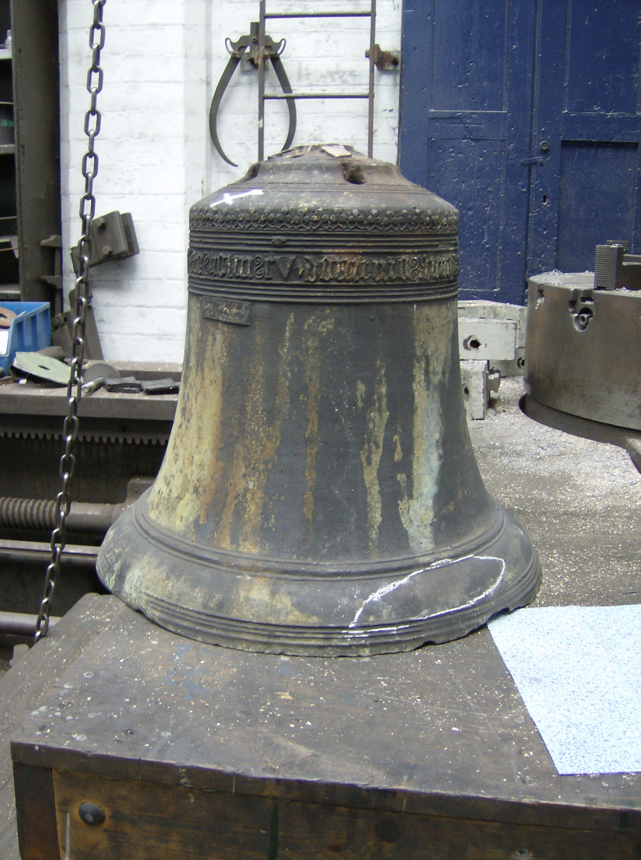

G A Dawson October 2007.

