A lost ring, St Thomas Church, Howrah, India?

The 1877 Catalogue issued by the bell-founders John Warner & Sons of London contains the following entry:

Howrah, Calcutta a ring of 5

This has long fascinated me as it implies another ring of bells on the Indian sub-continent, to go with the Taylor rings at Colaba (8), Lahore Cathedral (6) and Poona (8). The entry in Crockfords Clerical Directory gives a church of St Thomas in Howrah, across the river from Calcutta. Attempts to find more about this church have, until recently, resulted in failure.
However in October 2002, two of our church members here at Willoughby went to Calcutta for a couple of weeks and found time to find St Thomas’ church, located on Church Street. They had no bell ringing experience but came back with several photographs of the church.
The Tower at the west end is substantial and could easily contain five bells.
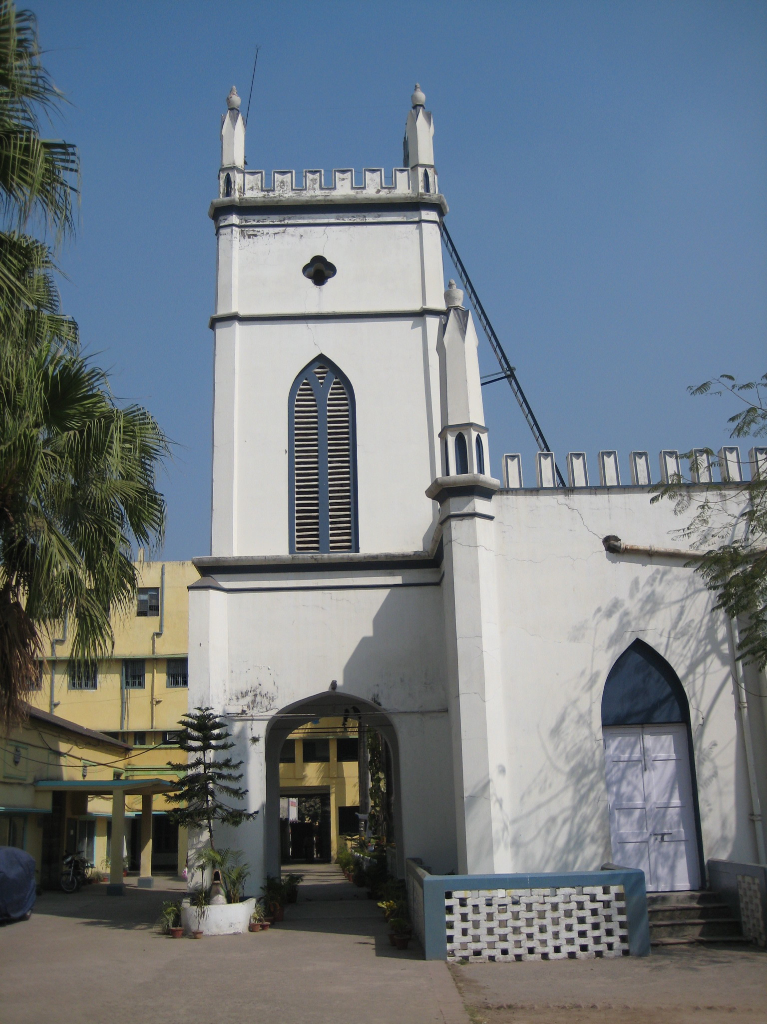
St Thomas’ Church, Howrah
Photo by P Rivet

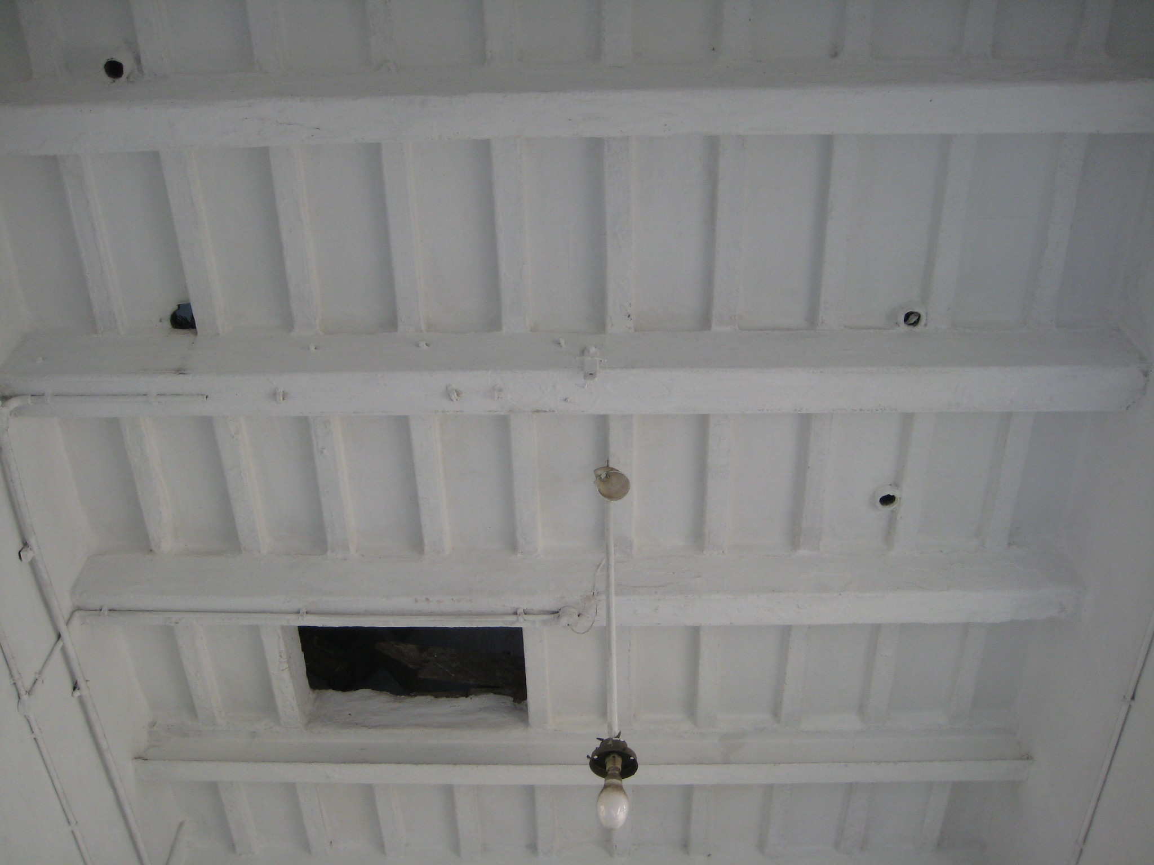

Inside the tower, looking up. Photo by P Rivet

In early 2010 Peter Rivet of Lancaster visited Howrah, and I quote verbatim from him:

I was able to have a brief look at St Thomas Howrah - the church is in the area behind Howrah Station and proved a bit easier to find than I had expected. It is behind the buildings of St Thomas Church School, which must have been built in what was originally the churchyard. I went there late on a Sunday morning but when I turned up the church was locked. There were several other people there waiting to get in as a service was due at about 11:30 - one of them was a very helpful guy who teaches International Relations at one of the local universities. He said that there used to be a bell or bells but that they weren't used and had been disposed of some time ago, he didn't know who to.

The church is as shown in your pictures except that it's undergone an extensive restoration. It appears to be early/mid 19th century but in the time available I wasn't able to find an exact date. Also when I was able to have a look inside the spiral staircase shown in one of your photos was nowhere to be seen. I think it must be in the vestry which I didn't have access to; it would give access to the roof rather than the tower.

What was really interesting was the ceiling of the open porch. It has four neat rope holes in exactly the places you would expect for a rope circle, three of them with bosses, plus a trap door opening (with no trap door in place) where you would look for a fifth. Through the opening I could see dimly the rickety remains of a wooden staircase and above it some beams, but no sign of any bells.

With a service due in about half an hour I couldn't readily negotiate a ladder to gain access to the upper part of the tower. However the evidence available indicates that there was indeed a ring of five here, rung from the open porch, but that whoever had the bells installed didn't manage to establish a band in the long term. Ringing there might have been pleasant enough in the November to February cool season, but I doubt it it would have appealed to many people in the hot summer or the monsoon...

So there we are, a lost ringable 5. Probably not rung full circle for a long time, if ever.

George A Dawson
2002
Revised 9.2010.

Acknowledgements: Peter Rivet for the photographs.

